**VAN HIEN UNIVERSITY**

**TECHNICAL – TECHNOLOGY DEPARTMENT**

-----🙞🙜🕮🙞🙜-----



**REPORT ON TECHNICAL ENGLISH FOR INFORMATION TECHNOLOGY**

**TOPIC:**

**SEARCH ENGINE OPTIMIZATION**

Instructor: Trần Thanh Trang

Participants: Lâm Sư Dương – 171A010103

Hà Văn Được – 181A010208

Nguyễn Lê Hải – 181A010071

Trần Vinh Hùng – 171A010026

Nguyễn Thanh Thuận – 181A010051

**TP.HCM, June 2020**

**VAN HIEN UNIVERSITY**

**TECHNICAL – TECHNOLOGY DEPARTMENT**

-----🙞🙜🕮🙞🙜-----



**REPORT ON TECHNICAL ENGLISH FOR INFORMATION TECHNOLOGY**

**TOPIC:**

**SEARCH ENGINE OPTIMIZATION**

Instructor: Trần Thanh Trang

Participants: Lâm Sư Dương – 171A010103

Hà Văn Được – 181A010208

Nguyễn Lê Hải – 181A010071

Trần Vinh Hùng – 171A010026

Nguyễn Thanh Thuận – 181A010051

**TP.HCM, June 2020**

**Table of Mission**

|  |  |  |  |
| --- | --- | --- | --- |
| **Student code** | **Name** | **Mission** | **Progress** |
| 181A010208 | Hà Văn Được | Overview of Search Engine Optimization | 100% |
| 171A010026 | Trần Vinh Hùng | Content development | 100% |
| 171A010103 | Lâm Sư Dương | Keyword research | 100% |
| 181A010071 | Nguyễn Lê Hải | Onpage | 100% |
| 181A010051 | Nguyễn Thanh Thuận | Offpage | 100% |

**Table of Contents**

[Chapter 1: INTRODUCTION 1](#_Toc45639992)

[Chapter 2: OVERVIEW OF SEARCH ENGINE OPTIMIZATION 2](#_Toc45639993)

[2.1 What is SEO ? 2](#_Toc45639994)

[2.2 Why is SEO important ? 3](#_Toc45639995)

[Chapter 3: THE SEARCH ENGINE OPTIMIZATION PROCESS 6](#_Toc45639996)

[3.1 Content development 6](#_Toc45639997)

[3.2 Keyword research 10](#_Toc45639998)

[3.3 SEO Onpage 21](#_Toc45639999)

[3.3.1 Technical optimization 23](#_Toc45640000)

[3.3.2 Content 24](#_Toc45640001)

[3.3.3 Internal links and structure 25](#_Toc45640002)

[3.3.4 Design 26](#_Toc45640003)

[3.4 SEO Offpage 27](#_Toc45640004)

[3.4.1 How to make Seo Offpage most effective? 28](#_Toc45640005)

[3.4.2 Key Factors In SEO OffPage 29](#_Toc45640006)

[Chapter 4: CONCLUSION 32](#_Toc45640007)

[References 33](#_Toc45640008)

# **Chapter 1: INTRODUCTION**

At present, information technology (IT) is present and plays an important role in the process of administration and administration of production and business activities of each enterprise. The development and application of the Internet has changed the business model and way of doing business, the gradual shift from traditional transactions to electronic transactions has affected the position, role and the demand. needs of stakeholders (customers, suppliers, investors ...) of the business.IT investment activities in the enterprise serve the business goals such as supporting operational activities, supporting management decision-making, and developing strategies to gain benefits competitive advantage, ...

Search engine optimization is considered as the most effective way of online marketing today. If your website appears on Google and all other search engines, you will get a great amount of free traffic from the internet - from which you can get a large number of customers and increase sales. . People who use search engines to search for products are often potential customers because they really need, so if your website does not appear on search engines, you miss out on those. Best customer, is also missing out on a big revenue stream. That's why many businesses focus on search engine optimization - this is a beneficial investment and the long-term impact of a business. Pay-per-click ads will only last when you have enough money to maintain that ad on search engines, while search engine optimization will help your product survive just Your website is still functioning.

Therefore, we have chosen topic is "Search Engine Optimization" to help you understand SEO work. Search engine optimization includes a lot of different jobs like natural links, content, website reliability,… However, in our report, we will present the following contents: content development, keyword research, onpage and offpage.

# **Chapter 2: OVERVIEW OF SEARCH ENGINE OPTIMIZATION**

## **2.1 What is SEO ?**

**SEO stands for Search Engine Optimization** (roughly translates to search engine optimization) is a collection of optimization methods to make the website become search engine friendly **(Search Engine)** from then improve. website rankings when users search with related keywords.

According to the definition of Wiki SEO is a set of methods to improve the ranking of a website in the search engine results pages (the most popular is Google). Such methods include optimizing the website (impacting HTML source code and website content) and building links to the page so that search engines choose the most appropriate website for Internet searchers for a specific keyword queryed by the user.

SEO is considered an area of ​​marketing, media and promotion, a good marketing profession for people who work on search engine optimization, who provide optimal methods for websites. Through SEO, administrators can put their website high on the SERP (Search engine result page) with related keywords to increase traffic and competitiveness. SEO is an independent job but sometimes also an advertising campaign of administrators. If the awareness of the importance of SEOtraining , the administrator will reap much success, earning a huge source of customers from search engines.

Currently, SEOservices in Vietnam are increasingly popular, it is considered as a job making money, a job full of thinking or a unique creative arts field. For businesses doing business on the Internet, howtoSEOkeywords to get high positions on the rankings of the search engines is extremely important. Most Internet users use search engines every day and can only look at the first page of search results. So if a customer is looking for your site, and you accidentally fall into the second page of search results, it is less likely that customers will visit your site.

## **2.2 Why is SEO important ?**

SEO includes a lot of benefits like:

* Cost savings

As you know, Google has a service that displays ads on the front page of the search results that we have to pay for each click (Pay Per Click - PPC) called  Google Adword . This can be a very good service to find potential customers for the website but the cost is quite high.

If you want to display the website at the top of the search results page without spending too much money, it is best to use SEOservices or self-SEO if you can.

* Targeting specific users

Compared to regular online advertising, such as posting ads on other websites. You will not be able to control your potential users. By choosing the right keywords, every time someone searches Google for information about a service they definitely want to use, you will be very lucky to display the first page of search results sword.

* Get a great deal of access

The writingStandardsSEO and optimization articles for friendly search queries will bring a massive traffic for your website.

* Long-term benefits

If you use PPC advertising programs to promote your website on search engines, you have to pay every day. But once you've applied SEO effectively to your website, your website will always be on the top of the search page without you having to pay anything to maintain it. Unless there is a better SEO competitor than you.

With more than 90% of Internet users in Vietnam using the information search tool before deciding to buy any product or service. Then to reach customers, the first thing is your website must appear in search results. That is why businesses interested in SEO help the website appear naturally on search results without spending human resources on this field.

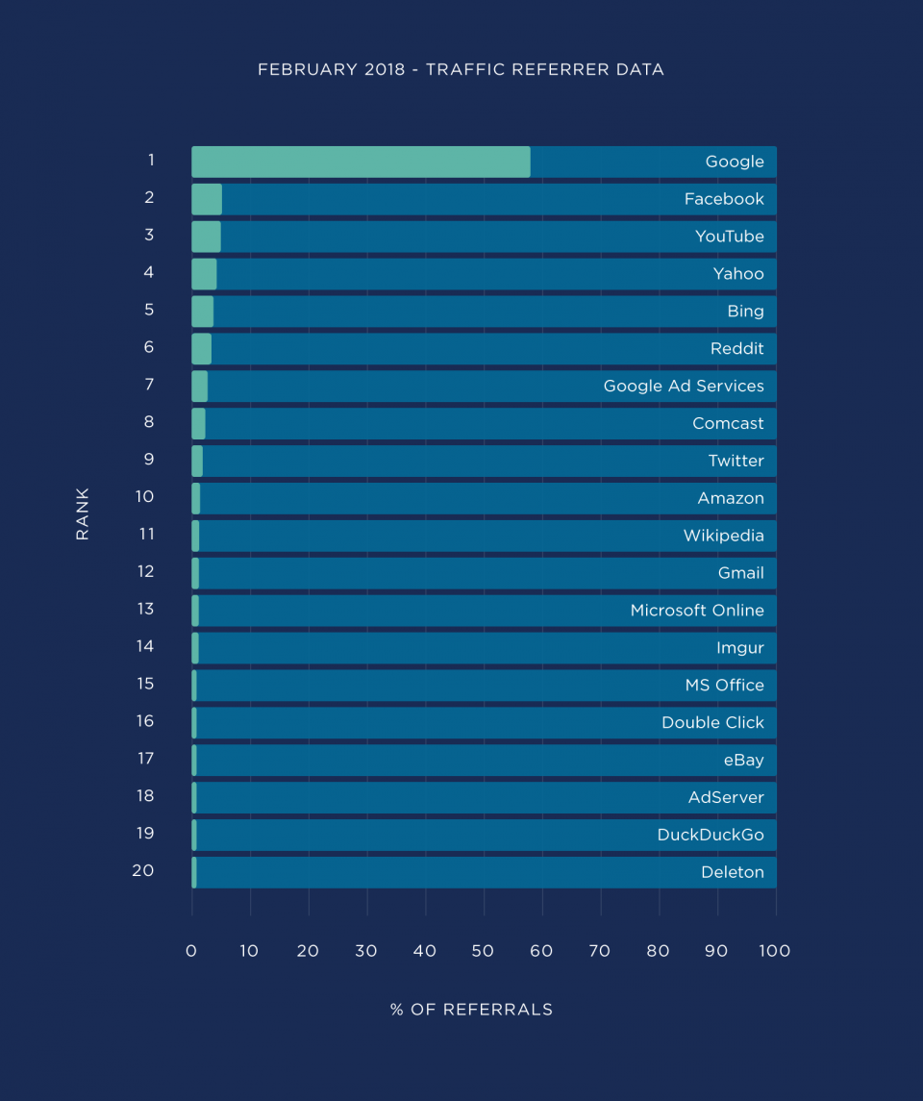

According to a report in February 2018, as you can see almost 60% of website traffic begins with Google search. And if you look broadly, you can see over 70% of the traffic coming to the website comes from search engines

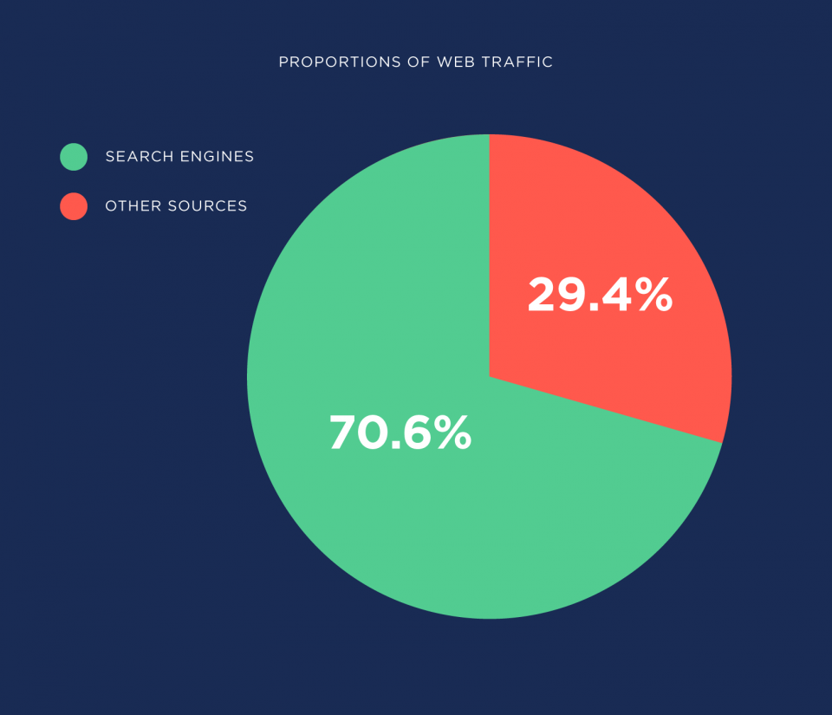

The more data people put online, a keyword can return hundreds of millions of results. What happens without SEO? Your website may be deep in the final results in search engines. So SEO is important!

# **Chapter 3: THE SEARCH ENGINE OPTIMIZATION PROCESS**

## **3.1 Content development**

**S.E.O Content**

“SEO” refers to search engine optimization, or [the process of optimizing a website](https://www.wordstream.com/blog/ws/2018/07/26/international-seo) so that people can easily find it via search engines like Google.

By “content,” we mean any information that lives on the web and can be consumed on the web ([more on the various types of content below](https://www.wordstream.com/blog/ws/2012/01/17/seo-content-beginners-guide" \l "types-of-seo-content)).



So, putting these two concepts together: SEO content is any content created with the goal of attracting [search engine traffic](http://marketing.wordstream.com/WSContentDL25WaysIncreaseTraffic.html?camplink=InContentCTA).

We aren’t going to tell you everything you need to know about optimizing your content for search engines here; that’s a whole ‘nother guide. But here’s a super-quick refresher on what you’ll need to do in order to SEO your web content:

* Keyword Research: If you want to [generate traffic through search](http://marketing.wordstream.com/WSContentDL25WaysIncreaseTraffic.html?camplink=InContentCTA), it’s best to do keyword research before you start writing. This way, you can focus on keywords for which a certain amount of search volume already exists – in other words, write toward topics (or find [keyword niches](https://www.wordstream.com/keyword-niche-finder)!) that people are already searching for information about.
* Keyword Optimization: Know where and how to use keywords in your content for maximum searchability. (SEOMoz offers a great guide to on-page optimization.)
* Content Organization: The content on your site should be organized in a logical way. This is not only [good for SEO,](https://www.wordstream.com/blog/ws/2018/06/20/seo-audit) it also helps visitors on your site find other related content easily. (The longer they stay on your site, the better.)
* [Content Promotion](https://www.wordstream.com/blog/ws/2014/03/26/content-promotion): Increase visibility to new content you create by sharing it on social networks and building links to your content (both internally and from external sites).

**Types of SEO Content**

SEO content can include any of the following:

* Product Pages – These are the bread and butter of any retail e-commerce site. A good product page can serve as both SEO content and a PPC landing page.  
   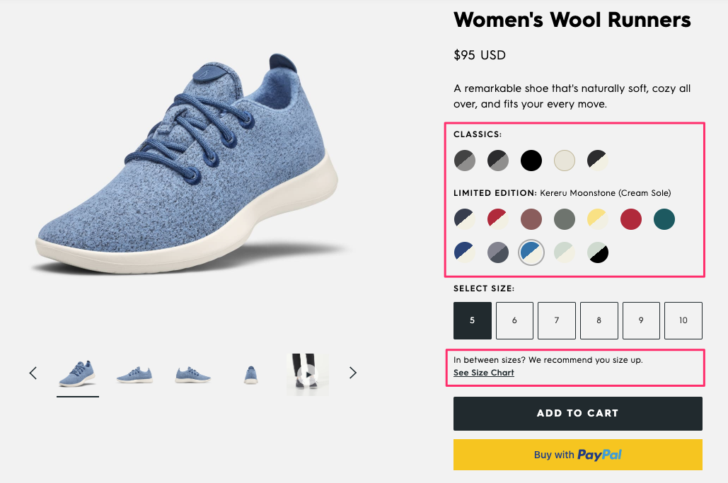
* Blog Posts – A blog is one of the easiest ways to create a regular stream of [effective SEO content](https://www.wordstream.com/blog/ws/2019/12/03/seo-copywriting). In general, blog posts are more engaging and more likely to attract links than product pages, so they can be a great way to build some authority for your site. (Keep in mind that blogs are very flexible, and you can use them to host any of the below types of content in this list.)
* Articles – Think news article, interview, or feature piece. This is the main kind of content you’ll find on most newspaper- or magazine-style websites.

 

* Lists – A list is really just a kind of article, but framing it as a list (such as “10 Ways to Lower Your Energy Bill” or “101 Things I Hate About Google”) makes it easier to scan. These types of titles also seem to be more clickable when found in search results or in social media feeds.
* Guides – A guide is a longer piece of content that explains in detail how to do something. (Guides are often broken up onto multiple web pages, though it’s a best practice to allow users to [view long content as a single page](https://www.wordstream.com/blog/ws/2011/09/16/google-tests-infinite-scroll-devalues-pagination) if they wish.) You can post a full guide on your website, or you can post a summary or excerpt, requiring visitors to fill out a registration form to read the full guide. This can be a good way to generate leads, but keep in mind that putting up a registration wall will likely reduce the amount of SEO traffic you can drive to that guide.
* Videos – In general there are fewer videos on the web than pages of text; consequently, it can be easier to rank on the first page for a competitive keyword by creating a video instead of an article. Depending on what type of site or business you run, videos can be a great way to attract and reach an audience. Consider creating video tutorials of how to use your products. Or illustrate a process that is related to your business – for example, a plumber could make a video showing how to unclog a sink. (A note on [SEO](https://www.wordstream.com/blog/ws/2019/08/01/seo-case-study): You might consider including a text transcript of your video. Here are some additional [tips for optimizing videos](https://www.wordstream.com/blog/ws/2012/01/11/rank-on-google-with-video-content-part-two).)
* Infographics – [Infographics](https://www.wordstream.com/blog/ws/2011/05/26/infographic-marketing-interview), or large-format images that contain a lot of data (often in the form of graphs or charts) on a single subject, can rack up a lot of page views and links. However, because so much of the content is embedded in the image and therefore not readable as text by search engines, it’s important to carefully optimize the rest of the page. You can use one of these five free [infographic templates](https://www.wordstream.com/blog/ws/2015/01/13/infographic-templates) to get started.
* Slideshows – A slideshow is a way to display a series of related images. Sometimes pictures are more important than text – say you’re trying to show what all the stars wore to the Oscars. Here again, SEO of your title, captions, image file names and so on is important because there is less for the search engines to “read.”
* Glossaries – I swear more people use Google to look up terms than they use a dictionary. (Do you even know where your dictionary is?) If you work in a specialized industry, a well built-out glossary can be a good way to capture some search traffic. Think cooking terms, medical terms, fashion terms, architectural terms …
* Directories – A directory is a useful taxonomy of links to sites or resources around a given topic. For example, a perfume blog might create a directory of places to buy perfume, from major department stores to independent shops around the country.

These are just some of the basic types of SEO content, but don’t let this list limit you – the possibilities are virtually endless.

## **3.2 Keyword research**

Now that you’ve learned how to show up in search results, let’s determine which strategic keywords to target in your website’s content, and how to craft that content to satisfy both users and search engines.

The power of keyword research lies in better understanding your target market and how they are searching for your content, services, or products.

Keyword research provides you with specific search data that can help you answer questions like:

* What are people searching for?
* How many people are searching for it?
* In what format do they want that information?

In this chapter, you'll get tools and strategies for uncovering that information, as well as learn tactics that'll help you avoid keyword research foibles and build strong content. Once you uncover how your target audience is searching for your content, you begin to uncover a whole new world of strategic SEO!

**Before keyword research, ask questions**

Before you can help a business grow through search engine optimization, you first have to understand who they are, who their customers are, and their goals.

This is where corners are often cut. Too many people bypass this crucial planning step because keyword research takes time, and why spend the time when you already know what you want to rank for?

The answer is that what you want to rank for and what your audience actually wants are often two wildly different things. Focusing on your audience and then using keyword data to hone those insights will make for much more successful campaigns than focusing on arbitrary keywords.

Here’s an example. Frankie & Jo’s (a Seattle-based vegan, gluten-free ice cream shop) has heard about SEO and wants help improving how and how often they show up in organic search results. In order to help them, you need to first understand a little more about their customers. To do so, you might ask questions such as:

* What types of ice cream, desserts, snacks, etc. are people searching for?
* Who is searching for these terms?
* When are people searching for ice cream, snacks, desserts, etc.?
  + Are there seasonality trends throughout the year?
* How are people searching for ice cream?
  + What words do they use?
  + What questions do they ask?
  + Are more searches performed on mobile devices?
* Why are people seeking ice cream?
  + Are individuals looking for health-conscious ice cream specifically or just looking to satisfy a sweet tooth?
* Where are potential customers located — locally, nationally, or internationally?

And finally — here's the kicker — how can you help provide the best content about ice cream to cultivate a community and fulfill what all those people are searching for? Asking these questions is a crucial planning step that will guide your keyword research and help you craft better content.

**Discovering keywords**

You likely have a few keywords in mind that you would like to rank for. These will be things like your products, services, or other topics your website addresses, and they are great seed keywords for your research, so start there! You can enter those keywords into keyword search tools to discover average monthly search volume and similar keywords. We’ll get into search volume in greater depth in the next section, but during the discovery phase, it can help you determine which variations of your keywords are most popular amongst searchers.

Once you enter in your seed keywords into a keyword research tool, you will begin to discover other keywords, common questions, and topics for your content that you might have otherwise missed.

Let’s use the example of a florist that specializes in weddings.

Typing “wedding” and “florist” into a keyword research tool, you may discover highly relevant, highly searched for related terms such as:

* Wedding bouquets
* Bridal flowers
* Wedding flower shop

In the process of discovering relevant keywords for your content, you will likely notice that the search volume of those keywords varies greatly. While you definitely want to target terms that your audience is searching for, in some cases, it may be more advantageous to target terms with lower search volume because they're far less competitive.

Since both high- and low-competition keywords can be advantageous for your website, learning more about search volume can help you prioritize keywords and pick the ones that will give your website the biggest strategic advantage.

**Understanding the long tail**

It would be great to rank #1 for the keyword "shoes"... or would it?

It's wonderful to deal with keywords that have 50,000 searches a month, or even 5,000 searches a month, but in reality, these popular search terms only make up a fraction of all searches performed on the web. In fact, keywords with very high search volumes may even indicate ambiguous intent, which, if you target these terms, it could put you at risk for drawing visitors to your site whose goals don't match the content your page provides.

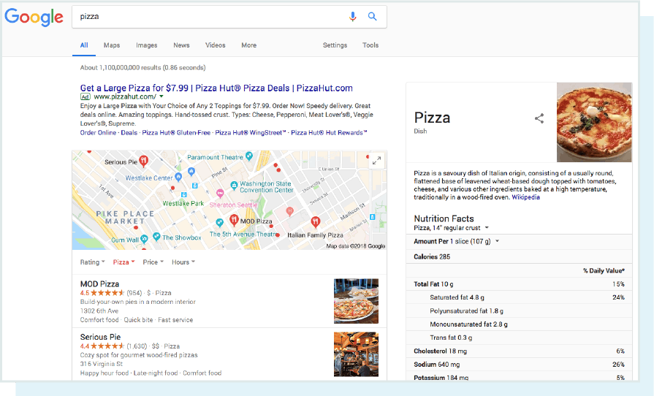

Does the searcher want to know the nutritional value of pizza? Order a pizza? Find a restaurant to take their family? Google doesn’t know, so they offer these features to help you refine. Targeting “pizza” means that you’re likely casting too wide a net.

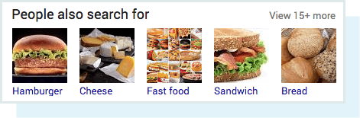

If you're searching for "pizza," Google thinks you may also be interested in "cheese." They're not wrong...

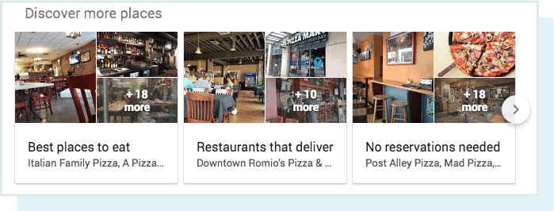

Was your intent to find a pizza place for lunch? The "Discover more places" SERP feature has that covered.

The remaining 75% lie in the "chunky middle" and "long tail" of search.

Don’t underestimate these less popular keywords. Long tail keywords with lower search volume often convert better, because searchers are more specific and intentional in their searches. For example, a person searching for "shoes" is probably just browsing. On the other hand, someone searching for "best price red womens size 7 running shoe" practically has their wallet out!

**Which format best suits the searcher's intent?**

In Chapter 2, we learned about SERP features. That background is going to help us understand how searchers want to consume information for a particular keyword. The format in which Google chooses to display search results depends on intent, and every query has a unique one. Google describes these intents in their Quality Rater Guidelines as either “know” (find information), “do” (accomplish a goal), “website” (find a specific website), or “visit-in-person” (visit a local business).

While there are thousands of possible search types, let’s take a closer look at five major categories of intent:

* **Informational queries:**

The searcher needs information, such as the name of a band or the height of the Empire State Building.

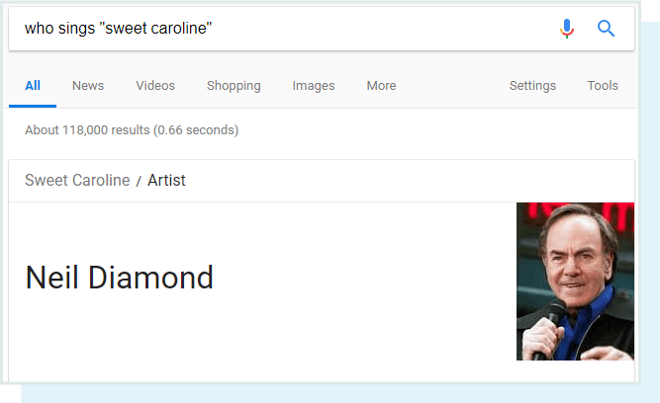

* **Navigational queries:**

The searcher wants to go to a particular place on the Internet, such as Facebook or the homepage of the NFL.

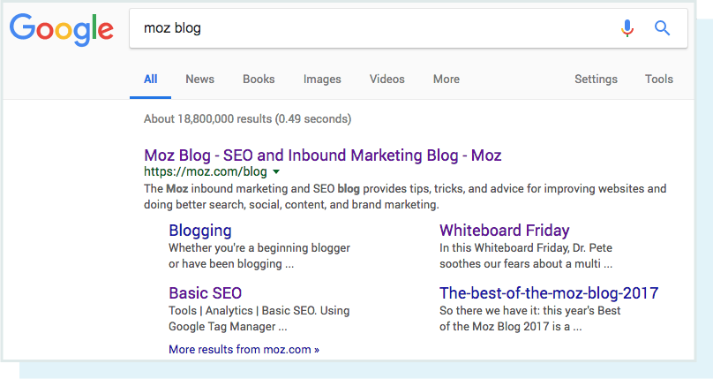

* **Transactional queries:**

The searcher wants to do something, such as buy a plane ticket or listen to a song.

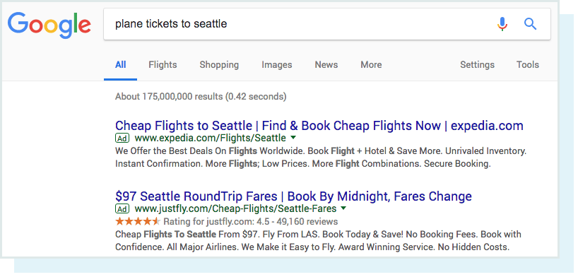

* **Commercial investigation:**

The searcher wants to compare products and find the best one for their specific needs.

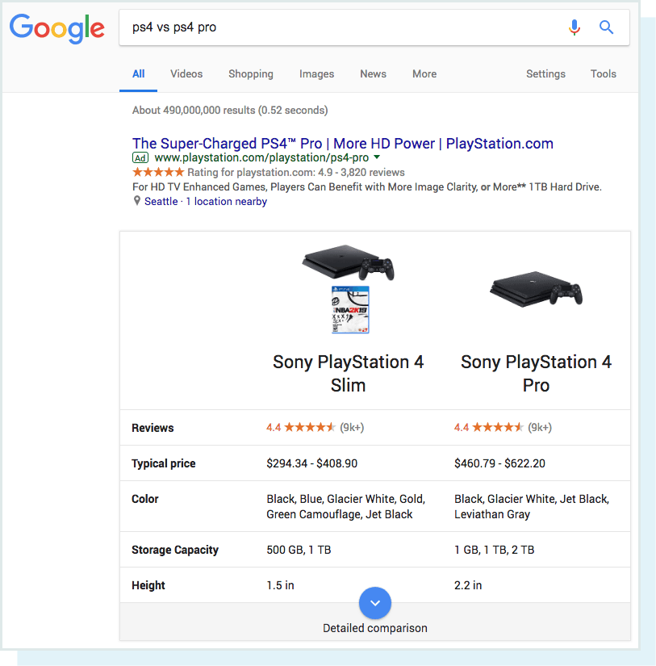

* **Local queries:**

The searcher wants to find something locally, such as a nearby coffee shop, doctor, or music venue.

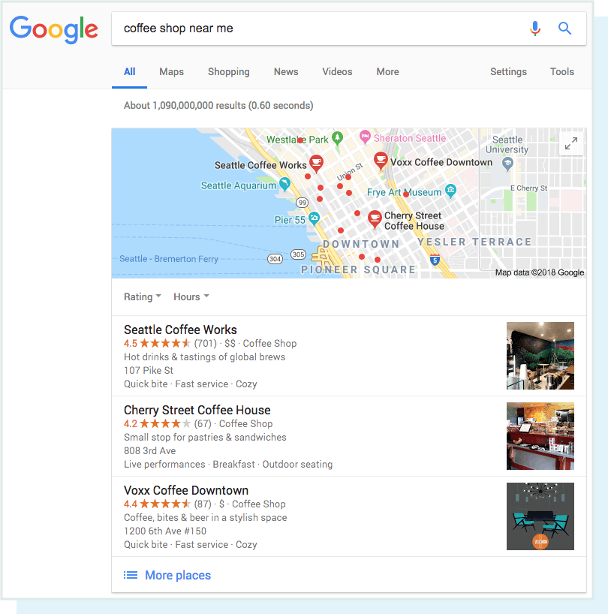

An important step in the keyword research process is surveying the SERP landscape for the keyword you want to target in order to get a better gauge of searcher intent. If you want to know what type of content your target audience wants, look to the SERPs!

Google has closely evaluated the behavior of trillions of searches in an attempt to provide the most desired content for each specific keyword search.

Take the search “dresses,” for example:

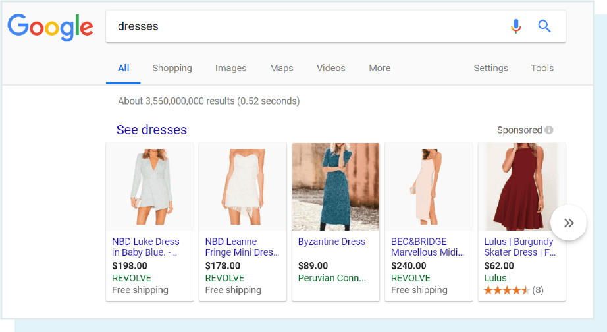

By the shopping carousel, you can infer that Google has determined many people who search for “dresses” want to shop for dresses online.

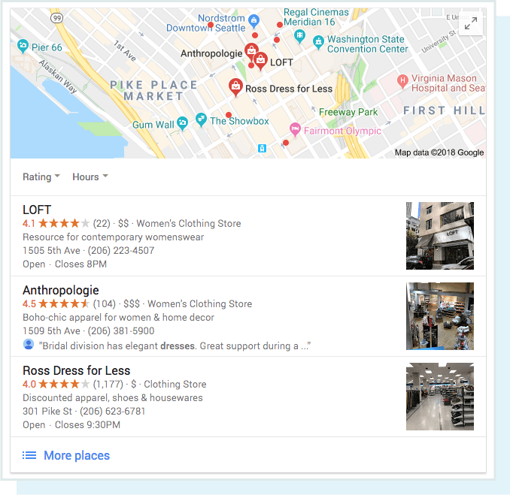

There is also a Local Pack feature for this keyword, indicating Google’s desire to help searchers who may be looking for local dress retailers.



If the query is ambiguous, Google will also sometimes include the “refine by” feature to help searchers specify what they’re looking for further. By doing so, the search engine can provide results that better help the searcher accomplish their task.

Google has a wide array of result types it can serve up depending on the query, so if you’re going to target a keyword, look to the SERP to understand what type of content you need to create.

**Tools for determining the value of a keyword**

How much value would a keyword add to your website? These tools can help you answer that question, so they’d make great additions to your keyword research arsenal:

* Moz Keyword Explorer - Input a keyword in Keyword Explorer and get information like monthly search volume and SERP features (like local packs or featured snippets) that are ranking for that term. The tool extracts accurate search volume data by using live clickstream data. To learn more about how we're producing our keyword data, check out Announcing Keyword Explorer.
  + **Bonus!** Keyword Explorer’s "Difficulty" score can also help you narrow down your keyword options to the phrases you have the best shot at ranking for. The higher a keyword’s score, the more difficult it would be to rank for that term. More about Keyword Difficulty.
* - Google's AdWords Keyword Planner has historically been the most common starting point for SEO keyword research. However, Keyword Planner does restrict search volume data by lumping keywords together into large search volume range buckets. To learn more, check out Google Keyword Planner’s Dirty Secrets.
* Google Trends - Google’s keyword trend tool is great for finding seasonal keyword fluctuations. For example, “funny halloween costume ideas” will peak in the weeks before Halloween.
* AnswerThePublic - This free tool populates commonly searched for questions around a specific keyword. Bonus! You can use this tool in tandem with another free tool, Keywords Everywhere, to prioritize ATP’s suggestions by search volume.
* SpyFu Keyword Research Tool - Provides some really neat competitive keyword data.

## **3.3 SEO Onpage**

Onpage SEO is all you can do on your website. All of the technical aspects of your website are very important for ranking in search engines. The advantage of doing WordPress is the Yoast SEO plugin. Installing this Plugin will cover most of the basic optimization techniques mentioned above.

Important impact factors with Onpage SEO

The structure of the site.

Content of the site.

Site speed.

The above factors all contribute an important evaluation for a website. Thereby can contribute to improve your website rankings

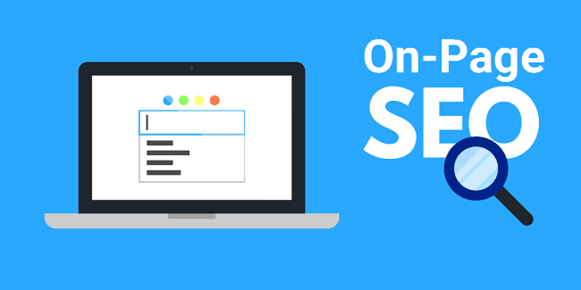

**Analysis and Monitoring as Prerequisites for Onpage Optimization**

Effective onpage optimization requires a combination of several factors. Two key things to have in place if you intend to improve your performance in a structured way are analysis and regular monitoring. There is little benefit in optimizing the structure or content of a website if the process isn’t geared towards achieving goals and isn’t built on a detailed assessment of the underlying issues.

In extreme cases, optimization measures that aren’t based on a solid, evidence-based plan can have the opposite effect to that desired – potentially harming the stability of keyword rankings or creating a drop in conversion rates.

Elements of Onpage Optimization

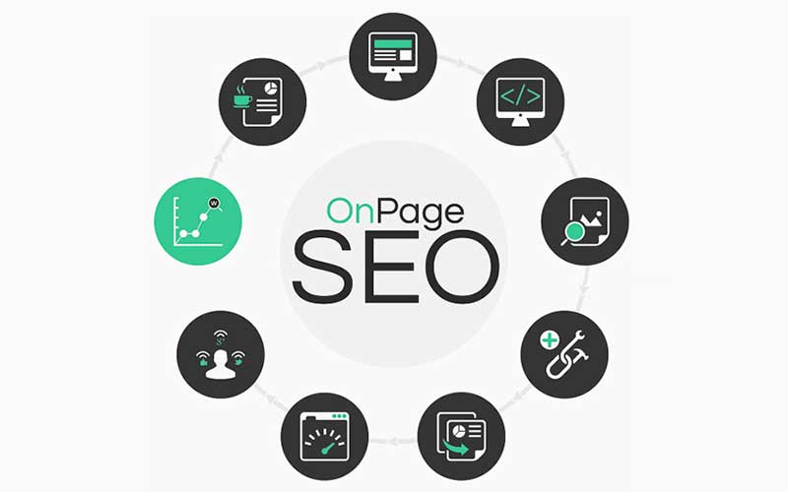

There is no standard, universally-recognized workflow for onpage optimization. However, analysis and measures for implementation should be as comprehensive as possible, to ensure that every opportunity is exploited for improving search engine rankings (or other KPIs).

Even if there is no simple step-by-step guide to improving the onpage aspects of websites, the following list attempts to cover the majority of the most common elements, sorted into four main areas:

### 3.3.1 Technical optimization

There are three main technical components of a [website](https://www.searchmetrics.com/glossary/website/" \t "_blank) that can be optimized:

* **Server speed**:

As website load times are considered by search engines as part of their evaluation for ranking purposes, speeding up server response times is an important part of onpage optimization.

* **Source code:**

An efficient source code can contribute to improved website performance. Superfluous functions or code sections can often be removed or other elements can be consolidated to make it easier for the Googlebot to index the site.

* **IP addresses:**

These can be used to find out if, for example, you have a [Bad Neighborhood](https://www.searchmetrics.com/glossary/bad-neighborhoods/" \t "_blank) issue. Ideally, you should always have a unique IP address for each web project. This signals to Google and other search engines that the website is unique.

### 3.3.2 Content

Content, in this context, doesn’t only refer to visible on-screen elements like texts and images. It also includes elements that are initially invisible, such as [alt-tags](https://www.searchmetrics.com/glossary/alt-attributes/" \t "_blank) or meta information.

* **Text:**

For a long time, text optimization was conducted on the basis of [keyword density](https://www.searchmetrics.com/glossary/keyword-density/" \t "_blank). This approach has now been superseded, firstly by weighting terms using WDF\*IDF tools and – at the next level – by applying topic cluster analyses to proof terms and relevant terms. The aim of text optimization should always be to create a text that is not only built around one keyword, but that covers term combinations and entire keyword clouds in the best way possible. This is how to ensure that the content describes a topic in the most accurate and holistic way it can. Today, it is no longer enough to optimize texts solely to meet the needs of search engines.

* **Structural text elements:**

This covers the use of paragraphs or bullet-point lists, h- heading tags and bolding or italicizing individual text elements or words.

* **Graphics:**

All images are important content elements that can be optimized. They can help to increase the relevance of the content and well-optimized images can rank on their own in Google’s image search. At the same time, they can increase how attractive a website appears to users. Appealing image galleries can also increase the time users spend on the site. File names of graphics are one part of image optimization.

* **Videos:**

Much of what applies to images also applies to videos. SEOs and webmasters should pay particular attention to ensuring that audiovisual content offered on their pages can actually be viewed by users.

* **Meta-tags:**

[Meta titles](https://www.searchmetrics.com/glossary/page-title/), as a page element relevant for rankings, and [meta descriptions](https://www.searchmetrics.com/glossary/meta-description/" \t "_blank), as an indirect factor that impacts the CTR (Click-Through Rate) in the search engine results pages, are two important components of onpage optimization. Even if they are not immediately visible to users, they are still considered part of the content because they should be optimized closely alongside the texts and images. This helps to ensure that there is close correspondence between the keywords and topics covered in the content and those used in the meta tags.

### 3.3.3 Internal links and structure

Internal linking can be used to guide a bot’s visit to your domain and also to optimize navigation for real users.

* **Logical structure and crawl depth**:

The aim here is to carefully structure menus and to ensure that a website hierarchy contains no more than four levels. The fewer levels there are, the more quickly a bot is able to reach and crawl all sub-pages.

* **Internal linking:**

This determines how link juice is managed and distributed around a domain and can help increase the relevance of a sub-page regarding a particular keyword. A good sitemap is one of the most important onpage SEO basics there is, and highly relevant, both for users trying to navigate around the domain and for search engine crawlers.

* **Canonization:**

Ways of avoiding [duplicate content](https://www.searchmetrics.com/glossary/duplicate-content/" \t "_blank) include the appropriate use of existing canonical tags and/or assigning pages with a noindex attribute.

* **URL structure:**

This aspect involves checking whether search-engine-friendly URLs are being used and whether the existing URLs are logically related to one another. URL length can also be looked at as part of onpage optimization.

* **Focus**:

Pages that don’t contain any particularly useful content and can be considered meaningless for the Google index, should be tagged with the robots metatag “noindex”, which will prevent them being included in the search results.

### 3.3.4 Design

A major factor in web design today is usability. Complex graphics (e.g. using Flash) are often replaced with more simple alternatives in order to increase the functionality of the page. The same can apply to other elements like JavaScript applications.

* **Mobile optimization:**

This means adapting a website’s desktop content so that it can be easily accessed and viewed on mobile devices like smartphones or tablet computers.

* **File sizes:**

Images or graphics that are too large can drastically increase the load time of a page. As part of their onpage optimization, SEOs and graphic designers should keep file sizes as small as possible.

* **Call-to-Action:**

Specific page elements should be used to stimulate a user action by encouraging interaction with the website. More information on onpage (and offpage) optimization can be found in our Searchmetrics Ranking Factors studies.

## **3.4 SEO Offpage**

Offpage Seo is the building of external links pointing to the Website. The goal is to increase the quality of the link system on landing pages from other websites to boost your keywords.



### 3.4.1 How to make Seo Offpage most effective?

Before doing Seo Offpage

First of all, we need to prepare for the important factors: Onpage optimization very well and identify the main keywords that you want to push to the top to use in anchor text when building backlinks, etc. to make the link. best building.

Next, you need to determine whether the anchor text that you will use to create backlinks is really the main keyword or not, exactly for the keywords you want to rank for. And the more important thing you should check the quality of the website that you will create backlinks with quality, not spam, relevant content with your page or not?



When starting to do SEO Offpage

- You should put the backlink in PR pages (reliability), small alexa (means with many visits).

- Once I have set the backlink, then pay attention to see if the page has rel = ‘nofollow’ attribute. Dofollow is better when you do backlinks. Because dofollow is only counted for backlinks, while nofollow only receives direct traffic, it only makes sense for the reader and Google will calculate the rank of your website when placing links to your other pages if you place dofollow.

- Avoid websites that change content frequently, have lots of flashes, and sites that have pornographic content.

- Placing in .edu or .gov websites is very beneficial because the Search engine appreciates the links from this page.

- Put in website with Age (age) as much as possible, age a factor for Google to evaluate the ranking of a website.

### 3.4.2 Key Factors In SEO OffPage

The Offpage content as the previous SEO techniques mentioned in this section I would like to say more clearly that it belongs to the Onpage. When an article is Onpage obviously its content must be unique, not copied, it does not need to be bothered by Onpage and tired of SEO or time consuming.

**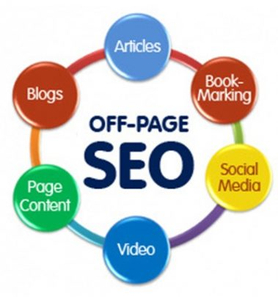**

* **Take advantage of Social media**

Social media is an open area of ​​land when Google Plus, Facebook, Twitter, etc. are the largest social networks on the planet to help you popularize your website. The number of people using these social networks is huge and has a good SEO impact, so you should quickly create a Fan Page on Facebook, Google Plus and take advantage of it.

* **Domain in offpage**

Previously, SEOer focused on buying a domain that contains keywords primarily and easily to the top when doing SEO. But now many years ago beautiful domain names containing keywords were almost bought by webmasters and domain name speculators, so this is not important anymore. A website with a good SEO strategy does not need to pay attention to buying domain names that contain keywords but focus on buying domain names related to the topic of the content that you provide during the development process. For example, domain tinhte.vn does not contain the keyword about introducing technology products, still developing well until today. Google cares about the brand you build and recognizes it through its popularity on social networking sites, SERPs, etc.

* **Directory Submission**

You need to choose the Directory Submission that match the topic and content that your website is providing. Use a unique description with the main language of the website on these DSs to brand your website better.

* **Exchange textlinks**

The exchange of textlinks between websites / blogs should be restricted to minimize the risk of a Google bot penalty without knowing the date of recovery. Create good relationships between websites / blogs with the same topic and focus more on your content to attract interested users to visit. Textlink increase rapidly in a short time will negatively affect the website (The amount of backlinks from many articles of any blog pointing to your landing page is so massive, and many links from many different sites like that in one short time, the consequences are not small, you should limit).

* **Blog comment**

Absolutely, do not use the expensive Auto Comment software, which negatively affects your website. Be honest when commenting and exchanging links in a quality way to retain backlinks later. The backlink has just appeared 1 week to help you increase the rank but then deleted by the other website owner for some reason will make you fall into a more miserable situation.

* **Anchor Text**

We should use a variety of Anchor Text that is most relevant to most keywords of the landing page and above all it should not be too far apart at least to have something related to each other. You note there will be some cases that happen to someone who only uses 1 Anchor Text when creating backlinks, the results appearing on SERPs will be Anchor Text and it is difficult for it to return to the title of the post. write as original. Use the code below to create effective backlinks targeting the Anchor Text that you need SEO.

# **Chapter 4: CONCLUSION**

Summary, Search Engine Optimization - Search engine optimization (SEO) is the process of increasing website quality and traffic by increasing the visibility of a [website](https://vi.wikipedia.org/wiki/Website) or [webpage](https://vi.wikipedia.org/wiki/Trang_web)for users on [search engines.](https://vi.wikipedia.org/wiki/M%C3%A1y_truy_t%C3%ACm_d%E1%BB%AF_li%E1%BB%87u) such as Google, Bing, Yahoo, etc. SEO is related to improving the search results for free ( ["natural" search results](https://vi.wikipedia.org/w/index.php?title=Organic_search&action=edit&redlink=1) ), excluding direct access sources and the purchase of [display advertising](https://vi.wikipedia.org/wiki/Qu%E1%BA%A3ng_c%C3%A1o_hi%E1%BB%83n_th%E1%BB%8B) . In addition, SEO techniques can be used for different types of searches, including image search, video, academic content, news, and search engine results by industry.

As an Internet marketing strategy, SEO looks at how it works, algorithms that control search engine behavior; what users search for, the terms or keywords entered and the preferred search engine of the target audience. SEO is used to improve website rankings on [the search engine results page](https://vi.wikipedia.org/wiki/Trang_k%E1%BA%BFt_qu%E1%BA%A3_c%E1%BB%A7a_c%C3%B4ng_c%E1%BB%A5_t%C3%ACm_ki%E1%BA%BFm) (SERP), thereby increasing traffic and the number of customers converted from this source.

In order to perform this job well, SEO practitioners need certain skills and expertise. Firstly, understanding and analyzing the website's code helps SEOs understand the nature of the Website to know which parts to upgrade and repair. Secondly, the skills of analyzing and measuring indicators help SEO-er track and understand the work efficiency and implement the optimization steps better. Besides, the ability to self-study for SEO is extremely important due to the peculiarities and continuous innovation in technology and algorithms that require the highest flexibility. At the same time, an SEO-er with content editing skills will know how to use keywords most effectively, help improve website quality to achieve a high position and optimize user experience.

# **References**

1. <https://thachpham.com/seo/tim-hieu-ve-seo.html>

2. <https://www.wordstream.com/blog/ws/2012/01/17/seo-content-beginners-guide>

3. <https://moz.com/beginners-guide-to-seo/keyword-research?fbclid=IwAR1MIBH_df9_wSI4MKbdN9NMillgIX8cLivZt_1XEtegX-V8PIb21mC0UYs>

4. <https://www.searchmetrics.com/glossary/on-page-optimization/?fbclid=IwAR2Uv8CkNgqSjsNoPJS1i6P4BD9Xfj6RWRGvWN9ouvMxJdCB-3W-lWMFsYc>

5. <https://jpwebseo.com/offpage-la-gi-trong-seo>

6. <https://seothetop.com/kien-thuc-seo/seo-la-gi-157055.html>

7. <https://seothetop.com/kien-thuc-seo/tong-quan-ve-seo-157067.html>

8.<https://vi.wikipedia.org/wiki/T%E1%BB%91i_%C6%B0u_h%C3%B3a_c%C3%B4ng_c%E1%BB%A5_t%C3%ACm_ki%E1%BA%BFm>

9. <https://wiki.matbao.net/seo-la-gi-tai-sao-noi-seo-rat-quan-trong-voi-moi-website/>

10. <https://gobranding.com.vn/seo-la-gi/>